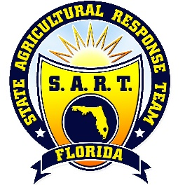
SART Strategic Planning
First-Year Timeline and Assignments
What is our timeline for completion of first-year accomplishments?
The group will work to determine when the accomplishments for each strategic direction will be completed and who will be responsible for it. This will help to continue building commitment and momentum.

January 23rd 10 - 12:30

10:00 – 10:15 Intros, Check-In, & Review
10:15 – 10:30 First-year Timeline and Assignments Process
10:30 – 11:00 Teamwork on Accomplishments Timeline
11:00 – 11:30 Team Reporting on Timeline
11:30 – 12:00 Timeline Coordination (Who is responsible?)
FDACS Decision Mechanisms for SART Overview (LeiAnna)
12:00 – 12:30 SART Business

